William Schulte

March 3, 2023

Activity 10

Exercise 3 –

The function is running our promise and testing whether or not it works, of which it does

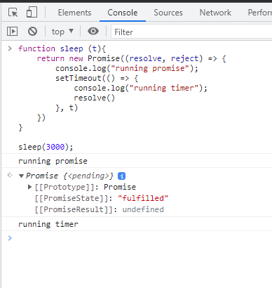

Exercise 4 –

Similar as above, the program runs the promise only this time we throw an error throught, causing a runtime conflict

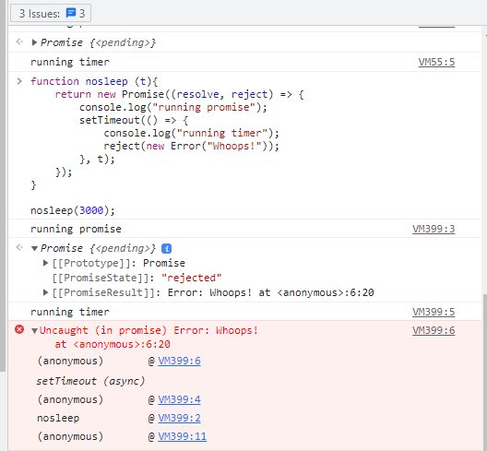

Exercise 5 –

It gives us a popup notification for it, only using a then statement within giving it a delayed response to when it should appear.

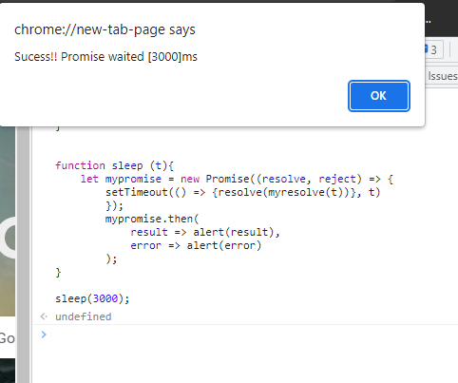

Exercise 6 –

Same as above, only this time displaying an error message.

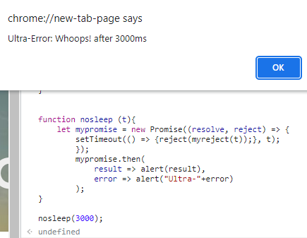

Exercise 7 –

We are essentially doing what we have been doing only this time we actually have out the code within a .js file.

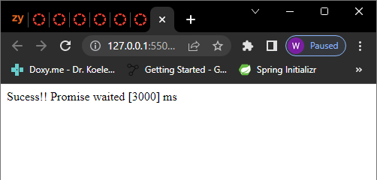  
(I also included my code for this as well, so that I have all my corners covered in regards to this exercise)